
Town Farm Primary School and Nursery

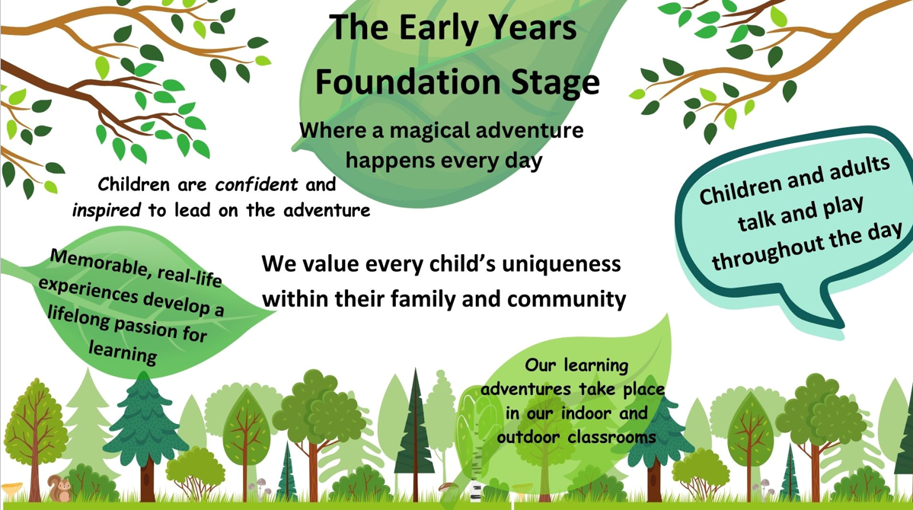

Nursery Handbook
2026-2027

This booklet has been produced to give you any additional information about Town Farm Nursery. Please visit the school website for additional information and to view the school prospectus.
The Nursery Staff Team
Mrs Barnes  EYFS Leader   | Miss Paice  Class Teacher  
Mrs Camara  EYFS TA   |  | Mrs Yassa  Nursery Nurse  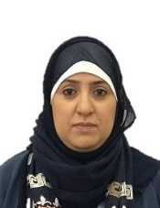

Nursery Session times:
The Nursery has space for 15 hour and 30-hour places which are split in 3 different ways:
Option 1 | Option 2 | Option 3
All day Monday and Tuesday (8.45am-3pm) and Wednesday morning (8.45am-11.30am)  15 hours | Wednesday afternoon (12.30-3pm), and all day Thursday and Friday (8.45am-3pm)  15 hours | All day Monday to Friday (8.45am-3pm)  30 hours

Please drop off and pick up your child as promptly as possible
School Uniform
In EYFS we now have one uniform that is worn each day (no separate PE uniform as our children are active every day. You can buy the school uniform from: https://www.schooluniformdirect.co.uk/schools/183/town-farm-primary-school
  TFPS Long Sleeved Top | 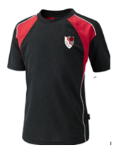  TFPS Short Sleeved Top
  Plain Black Tracksuit Trousers  (Not leggings) |   Plain Black Shorts/ Skort
  Black Socks |   Plain Black Trainers or Shoes  No Laces

Children will also need a warm waterproof coat (any colour), school book bag, water bottle, welly boots and their spare clothes bag.
All items must be named
Early Years Foundation Stage Areas
Children experience seven areas of learning in Nursery. All areas of learning and development are important and inter-connected. Three areas are particularly crucial for igniting children’s curiosity and enthusiasm for learning, and for building their capacity to learn, form relationships and thrive.

In Nursery we focus on the three prime areas initially:
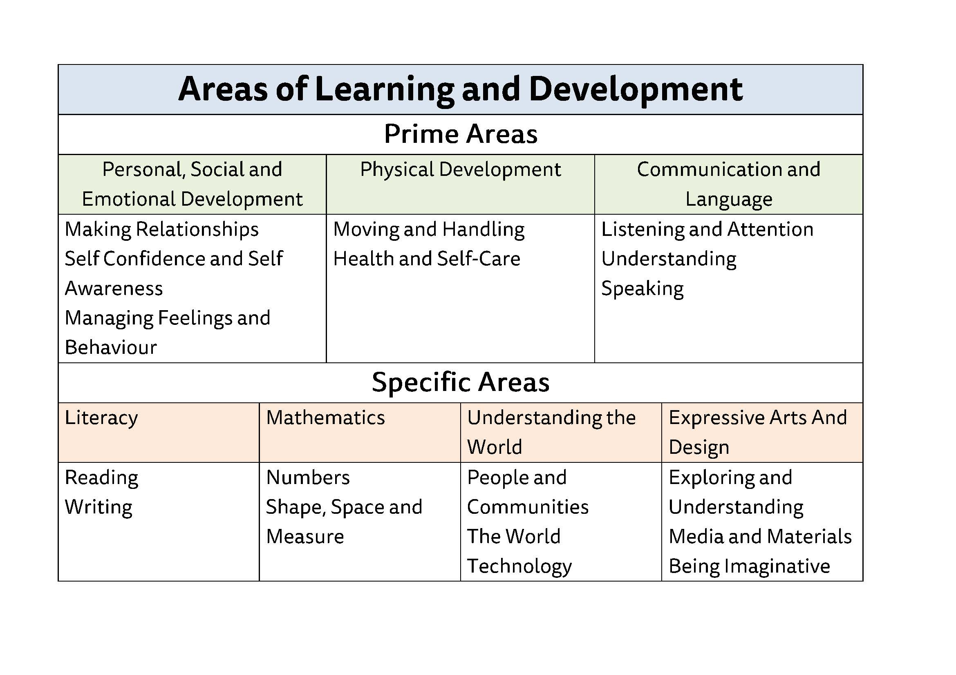

Then support the children in four specific areas, that build on the prime areas.
Learning in Nursery
In Nursery we learn through focused teaching sessions on the carpet that are adult lead – our topics are carefully selected to inspire and engage our children and centre around high quality books. We also learn through play in both the indoor and outdoor classrooms – play is child lead and adults interact with the children to support, challenge and extend.



What can parents do to help

- Share the books that your child chooses from the library at home.
- Complete the home learning challenges with your child.
- Hand your child over to our experienced team, when you arrive at Nursery, they will be able to settle your child quickly.

- Discourage your child from bringing toys to Nursery.
- Share the observations on Tapestry with your child and upload significant moments from home.


Lunchtimes
There are 2 options for lunch:
School Dinners | Packed Lunch
this academic year it costs £2.95 (this may change for 2025-26) please speak to the office on how to set up the online payment for this. | parents provide these every day, please ensure they are healthy (no sweets chocolate etc) and must be nut free (including chocolate spreads that contain nuts.

Milk and Snack
We provide a fruit snack in the afternoon. If you would like your child to have milk you can register them on the website.


Attendance and Illness
Please phone the school and inform the office if your child is unable to attend and state the reason why. This must be done every day your child is not attending.
Please note that following sickness/ diarrhoea your child needs to have been clear of symptoms for 48 hours before returning to school
. How Our Learning Environment Looks Inside
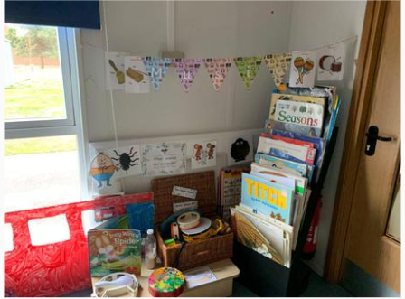
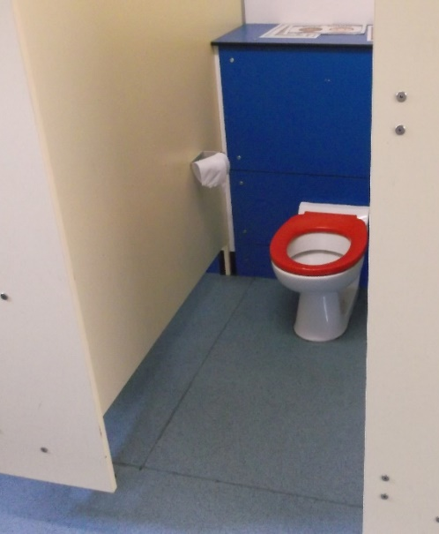

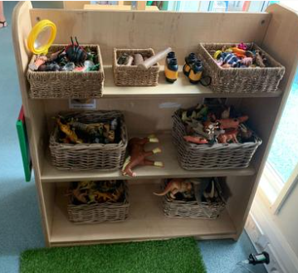
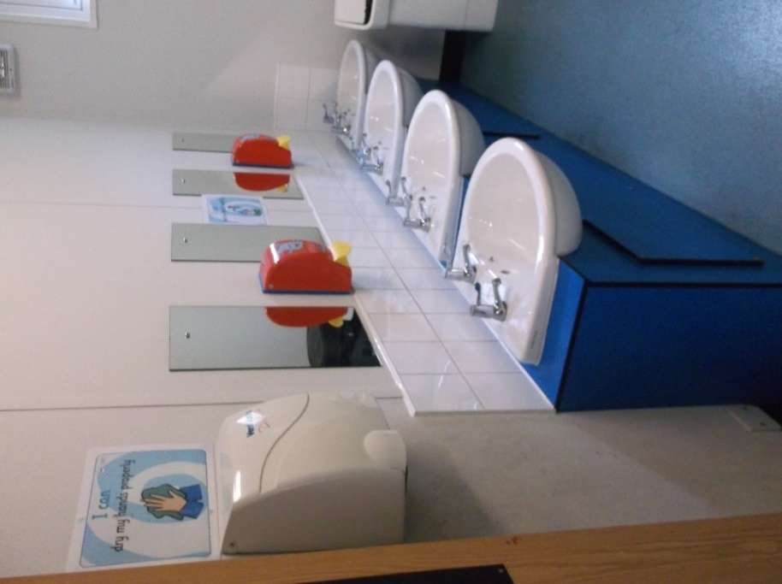

How Our Learning Environment Looks Outside

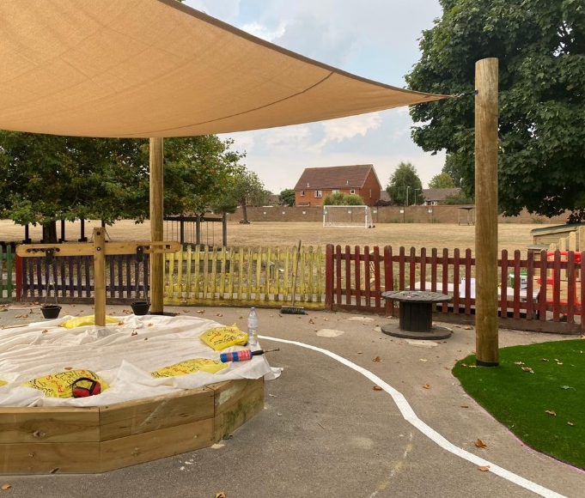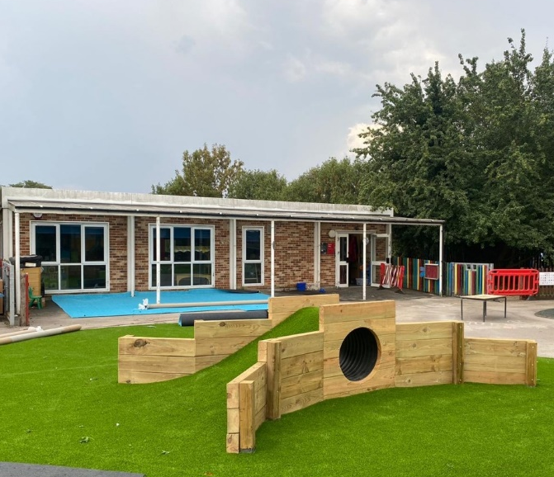

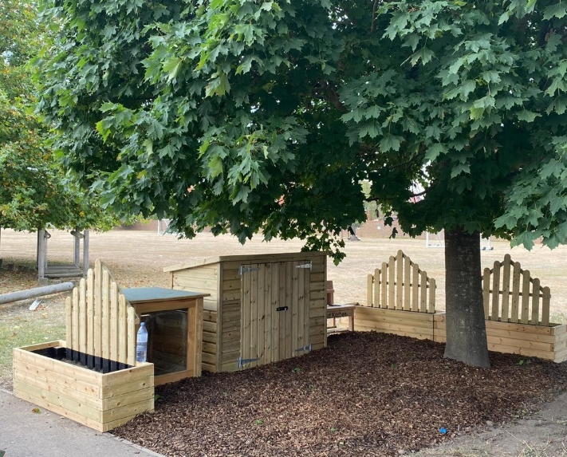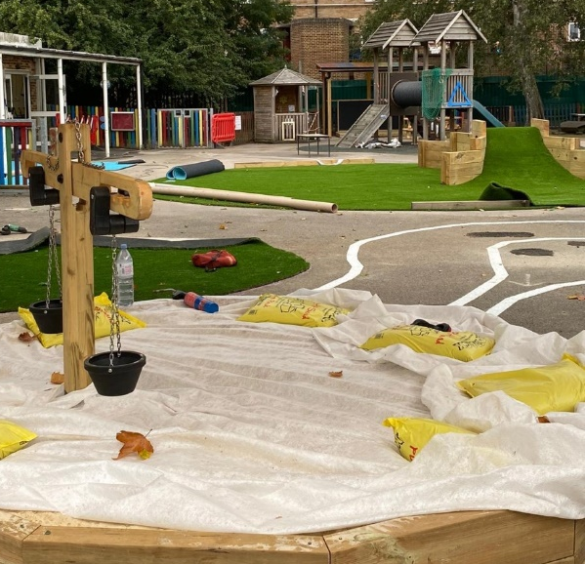

If you have any further questions please speak to a member of staff.

