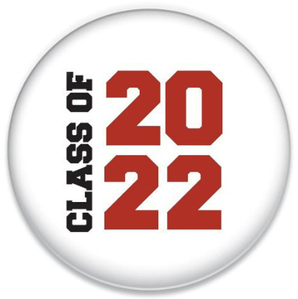
Hello Year 6 Darwin and Hillary Class
We had an incredible time at the gala with you on Friday and celebrating the success of your fantastic Zoom! Production.
We have set below 4 tasks that can be completed across the two days you are learning from home.
Task 1
LEAVERS ASSEMBLY
Our final big event is our Leaver’s Assembly (Wednesday at 11am)which we now need to rehearse. Please learn and practice the following songs:
- Daddy Tortoise - Zoom
- Evergreen Valley – Zoom
- Matilda – When I grow up - Matilda - When I Grow Up with lyrics - YouTube
- Bruno Mars – Count on me Bruno Mars - Count on me lyrics - YouTube
- Give it all you got – Town Farm Song (at bottom)
Remember to bring in a ‘proud moment’ item if you do not have a photocopied piece of work from your book – you would have already discussed this with your class teacher.
Task 2
DREAM BIG!
Reflect upon the careers you heard about and perhaps you may have an idea about a career you would like to pursue. Make a fact file about a career of your choice – remember to search safely online using Kiddle as your search engine.
Task 3
OPTICAL ILLUSION ART
Try create your own optical illusions with just a penci/pen and piece of paper at home. Please bring into school on Wednesday. Op Art Shaded Shapes Lesson Plan. KinderArt.com
Task 4
FLUENCY REVISION
Play Top marks maths online – Maths - Topmarks Search
Donate Rice – by answering English questions online you can feed the world as every correct answer donates grains of rice. Find out more here - Freerice

Please remember to stay safe as it will be very hot outside.
Stay in the shade, wear sunscreen with a high UV rating, wear a hat and sunglasses, keep cool, drink plenty of water to stay hydrated and wear loose fitting clothing. More tips here: UK heatwave: How to stay safe in the sun - CBBC Newsround
See you Wednesday!
Mrs Ravenor and Mr McMahon



