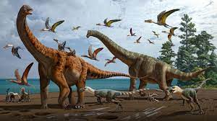
Dinosaurs
Listen to some dinosaur stories:
Tyrannosaurus Drip | Bedtime Stories for kids - YouTube

The Dinosaur Who Lost His Roar - Give Us A Story! - YouTube

Stomp, Dinosaur, Stomp! - Give Us A Story! - YouTube

🦖Tiny T Rex and The Impossible Hug (Read Aloud books for children) | Dinosaur Stutzman Miss Jill - YouTube

Crunch Munch Dinosaur Lunch! - Give Us A Story! - YouTube

The Dinosaur that Pooped a Planet. Tom Fletcher & Dougie Poynter. Hilarious audiobook, read-aloud. - YouTube

Allosaurus - The Troublesome Tooth - Dinosaur Story - Dino Storytime. @Bedtime Kidstime - YouTube

🦎 Dinosaur Story | Harry and the Bucketful of Dinosaurs read aloud by Books Read Aloud For Kids - YouTube

Children's book read aloud.' How Do Dinosaurs Eat Their Food?' - YouTube

A Read Aloud of "If the Dinosaurs Came Back" by Bernard Most - YouTube

Dragons Love Tacos 🌮by Adam Rubin (Read Aloud) | Storytime |Miss Jill Taco Tuesday - YouTube

Ten Terrible Dinosaurs | Rhino Read Aloud Book - YouTube

Reading books
Some useful website to look at for reading and developing our phonics:
Oxford owl reading books – Free eBook library | Oxford Owl from Oxford University Press
RWI phonics sessions – Parent video: Sound blending - YouTube
Alphablocks - Alphablocks - YouTube
The Book Trust - Stories for kids online and fun games to play | BookTrust
Mark Making Tasks
Drawing: can you draw a dinosaur and a nest with dinosaur eggs in it? Where might the nest be? What colours would you need to use?
Labelling: Can you draw your own dinosaur and label it? Sound out the words using a sound mat. Use your Fred Fingers to support. For example – claw = c-l-aw
Writing about your Dinosaur Is your dinosaur good or bad? What might your dinosaur get up to? Can you write some sentences about your dinosaur?
Story map: Listen to the story of Harry and a bucket full of dinosaurs. What happens in the story? What is at the beginning of the story? What happens in the middle of the story? What happens at the end of the story?
Writing a list: can you write a list of all the things that dinosaurs might like to eat?
Writing a recipe: what might Harry like to make for the dinosaur’s dinner? Can you make up your own recipe?
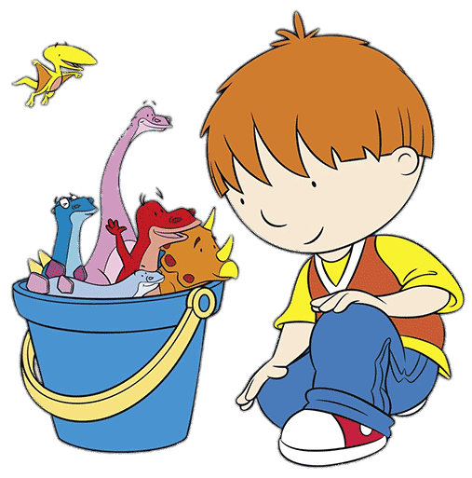
Maths Activities
We are learning about 3D shapes. Can you learn the names of these shapes and talk about them?
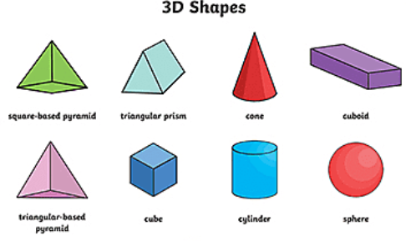

How do you know it is a cube? It has 8 corners and 6 flat sides that are all squares.
Can you go on a 3D shape hunt and see what shapes you have in your home?
Sing along with the 3D shape song: 3D Shapes Song | Shapes for kids | The Singing Walrus - YouTube

Expressive Arts Choices
Can you make some dinosaurs? What could you use to make them?
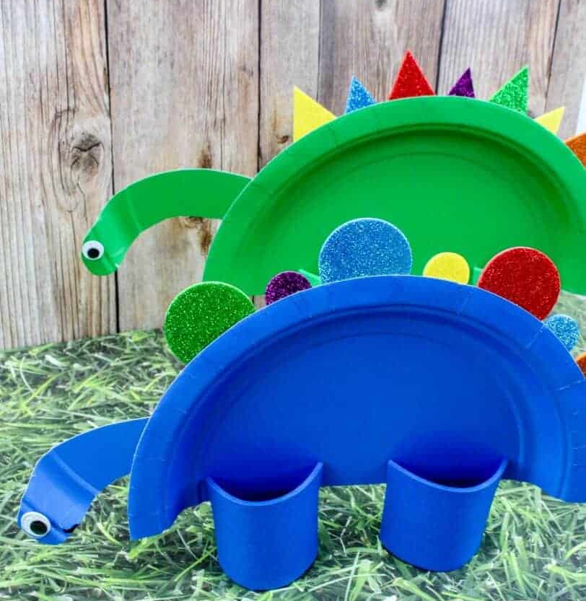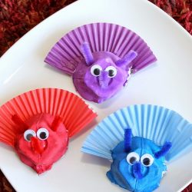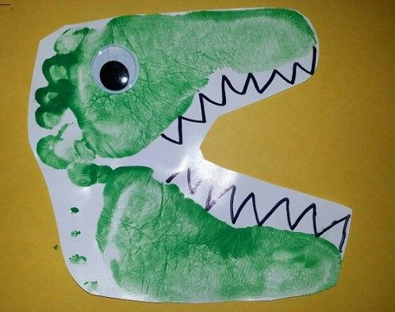
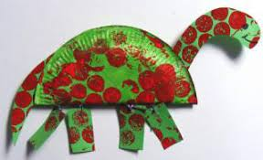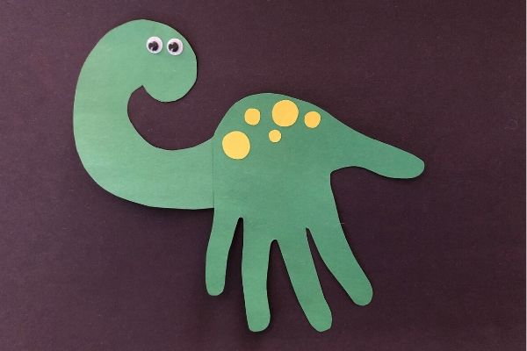

Take photos of all your amazing learning at home and upload to EExAT for us to see Thank you!

