Summer Week 1
In the hot weather we would like you to do some learning at home. We thought it might be fun to learn about rainbows.
Skittles Rainbows
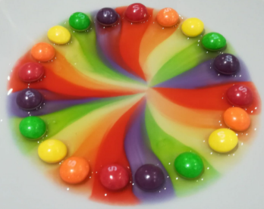
Make a pattern or shape with some skittles on a white plate. Add some water or milk to the middle. What happens to the skittles? Can you draw what happens? If you tried water, can you see the difference between warm and cold water? What about cold milk and cold water?

Story time
Listen to the following stories and try to draw a story map of your favourite one. I love the rainbow fish story as she has lots of shiny colourful scales.
How the Crayons Saved the Rainbow Read Aloud - YouTube
Spike: The Penguin with rainbow hair | A story about acceptance & loving who you are - YouTube
Elmer and the Rainbow - Bedtime stories for kids, read aloud. - YouTube
The Rainbow Fish (HQ) - YouTube
The Rainbow Fish (HQ) - YouTube

Mark making
- Can you draw your own story map of your favourite story? Use your Fred fingers to try and sound out some words or sentences.
- Can you draw your own rainbow and try to write the different colours that you had in it?
- Can you find your items that are your favourite colour around your house and draw some pictures? Can you write about why they are your favourite. Try to use the word ‘because’.
- Can you write a recipe for a rainbow fruit salad? What could you add into it? Can you try making this with an adult?

Maths Activities
This week we are focusing on our numbers to 20. Listen to our favourite number songs below.
Write your own number line to 20
Find 20 objects and practise putting them in order from 0 to 20
Have a go at adding some numbers together.
Can you have a go at taking away within 20?
Can you try and write some number sentences for these?
Number song 1-20 for children | Counting numbers | The Singing Walrus - YouTube
LEARN TO COUNT 1-20 Pirate Song for Kids | Counting to 20 for preschool, kindergarten, home school - YouTube
Counting Numbers | Numbers 1-20 Lesson for Children - YouTube
Expressive Arts Choices
Can you make some rainbows or make some pictures using your favourite colours? Take lots of pictures to upload to EEXAT.
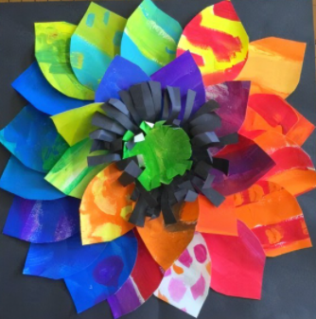
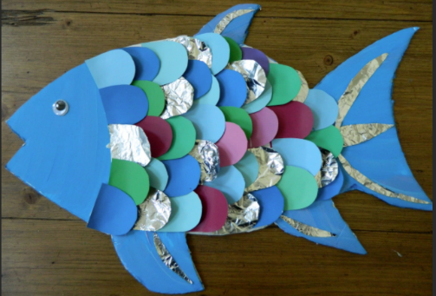
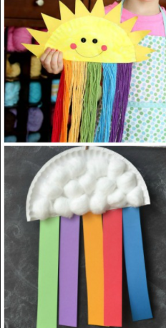

Take photos of all your amazing learning at home and upload to EExAT for us to see Thank you!

